**Speech color sorter**

**1. Purpose**

In this lesson, we will learn how to use Arduino UNO drive the speech synthesis module, color recognition module and button module to realize the speech color sorter function.

**2. Preparation**

The I2C communication used by speech synthesis module module.

|  |  |
| --- | --- |
| Speech synthesis module | Arduino UNO board |
| SCL | SDA |
| SDA | SCL |
| VCC | 5V |
| GND | GND |

|  |  |
| --- | --- |
| Color recognition module | Arduino UNO board |
| SCL | SDA |
| SDA | SCL |
| VCC | 5V |
| GND | GND |

|  |  |
| --- | --- |
| Button module | Arduino UNO board |
| OUT | Pin 6 |
| VCC | 5V |
| GND | GND |

****3. S**peech synthesis **module protocol****

The speech synthesis module is configured and used in accordance with the specified data frame through the I2C communication.

More details, please check [1.Introduction]--[1.2Communication protocol].

1. **About code**

Please check .ino file

**5. Compiling and downloading code**

We need to open the .ino file by Arduino IDE software. Then, click“√”under the menu bar to compile the code, and wait for the word "Done compiling " in the lower left corner, as shown in the figure below.

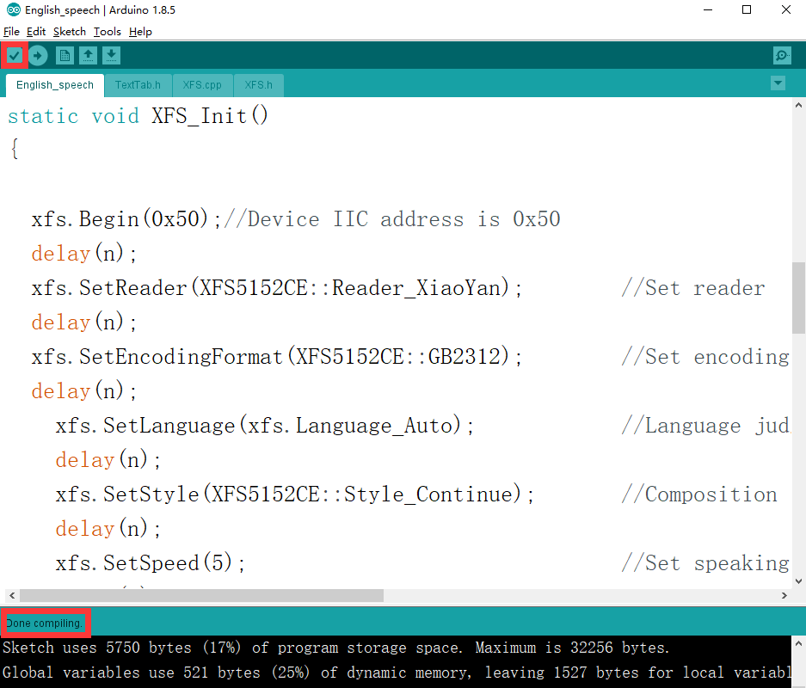5.2 In the menu bar of Arduino IDE, we need to select 【Tools】---【Port】--- selecting the port that the serial number displayed by the device manager just now, as shown in the figure below.

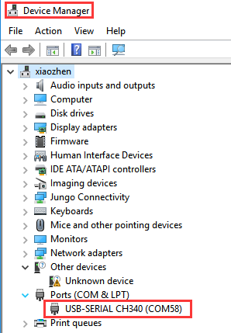

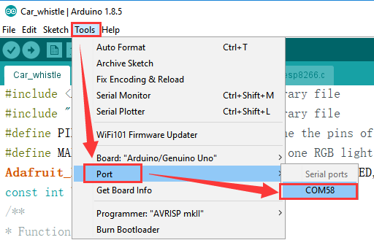

5.3 After the selection is completed, you need to click “→”under the menu bar to upload the code to the UNO board. When the word “Done uploading” appears in the lower left corner, the code has been successfully uploaded to the UNO board, as shown in the figure below.

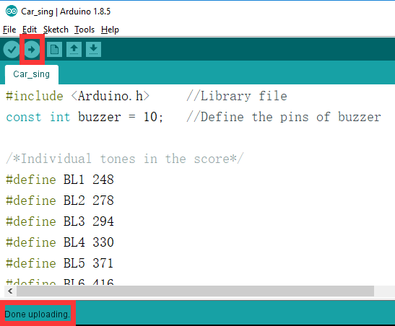

**6. **Experimental phenomena****

After the program is downloaded successfully, micro:bit will display a smile face.

When the button A is pressed, the Color recognition function will be started.

If it is red, it will broadcast “red”. if it is green, it will broadcast “green”. if it is blue, it will broadcast “blue”.